

**AMERICAN INTERNATIONAL UNIVERSITY-BANGLADESH**

**DIGITAL LOGIC DESIGN LABORATORY**

**Experiment No:** 02

**Section:** B

**Semester:** Fall 2021-22

**Experiment Name: Study of Universal Gates.**

**Submitted by: Izu, Humam Ahmed**

## Submitted to: Dr. Ferdous Jahan Shaun

## Date of Experiment: 20-September-2021

## Date of Submission: 27-September-2021

**Group No: C**

|  |  |  |  |
| --- | --- | --- | --- |
| **SL NO** | **NAME** | **ID** | **Department** |
| 1 | Rishad, Md. Yashir Arafat | 18-37677-1 | CSE |
| 2 | Pushan, Mahathir Shams | 18-37220-1 | CSE |
| 3 | Md Saiful Islam | 18-36363-1 | CSE |
| 4 | Sadek Islam | 17-35436-3 | CSE |
| 5 | Izu, Humam Ahmed | 17-34148-1 | CSE |
| 6 | Moktadir, Md. Golam | 18-37211-1 | CSE |
| 7 | Sunny, Fazle Rabbi | 16-32822-3 | CSSE |
| 8 | Pritom, Sadi Mohammed | 18-37236-1 | CSE |
| 9 | Rasel,Md. AMINUL | 18-37723-1 | CSE |

1. **Abstract:**

To learn about the universal gates in this experiment universal gates were used and implemented them in the trainer board. NAND gates were used to constructed an XOR and XNOR gate in trainer board. NOR gates were used to found out the equivalent NOT, OR, AND gates. The truth table was verified.

1. **Objective:**
   1. To learn the properties of universal gates.
   2. To put inputs and outputs to the test.
2. **Results:**
   1. Simulation Environment: Proteus Professional Software version 8.9 was utilized to simulate this assignment. 2D circuits can be constructed with this simulation software.
   2. Simulation Results:

**NAND GATE**

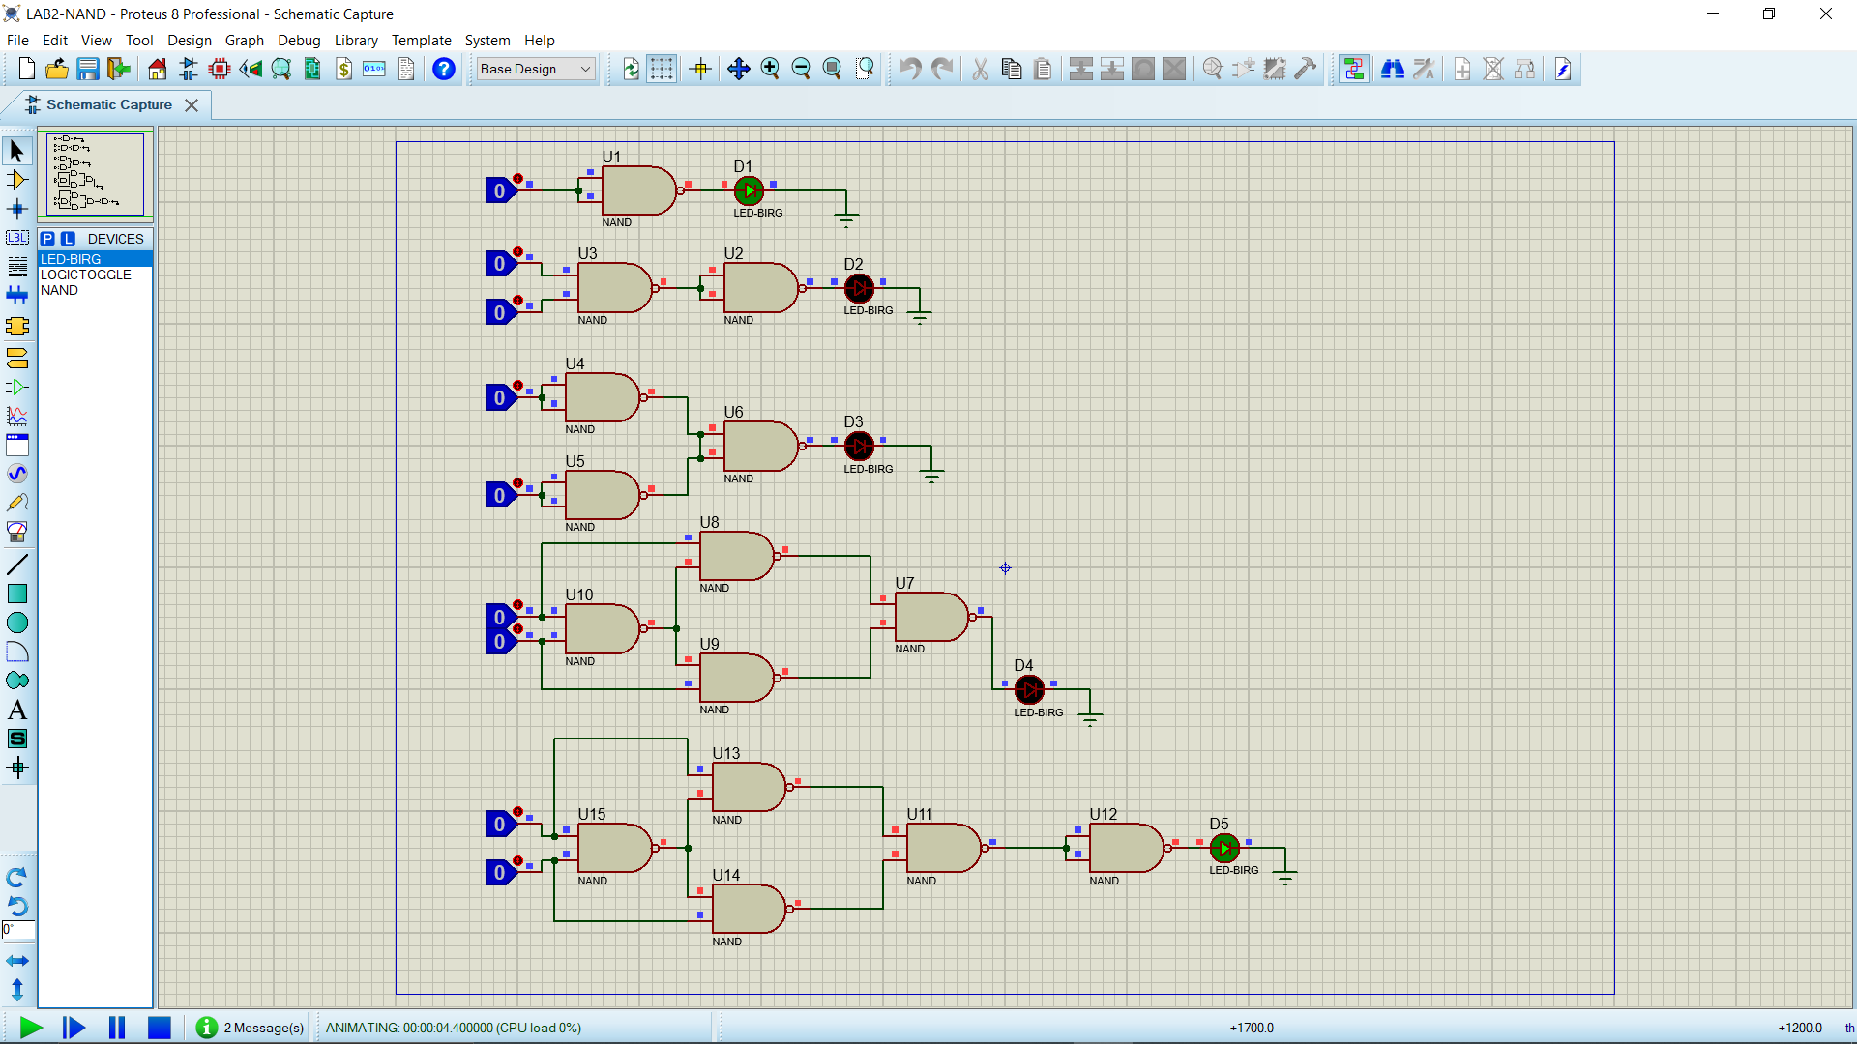

Figure 1: For Input A=0, Input B=0.

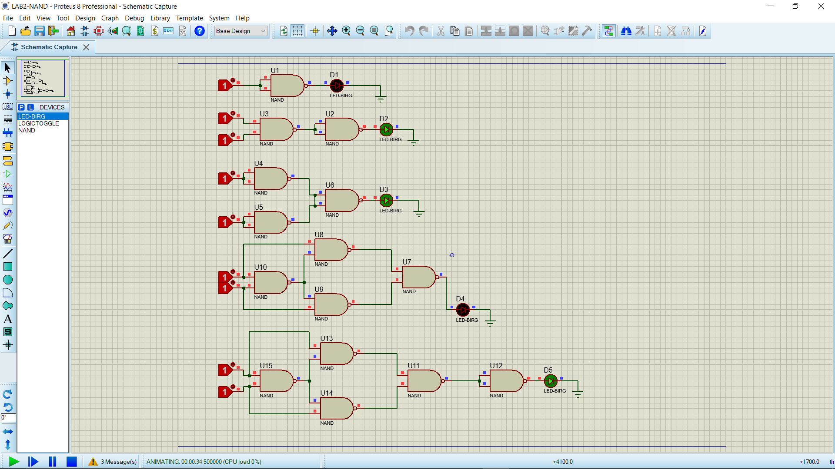

Figure 2: For Input A=1, Input B=1.

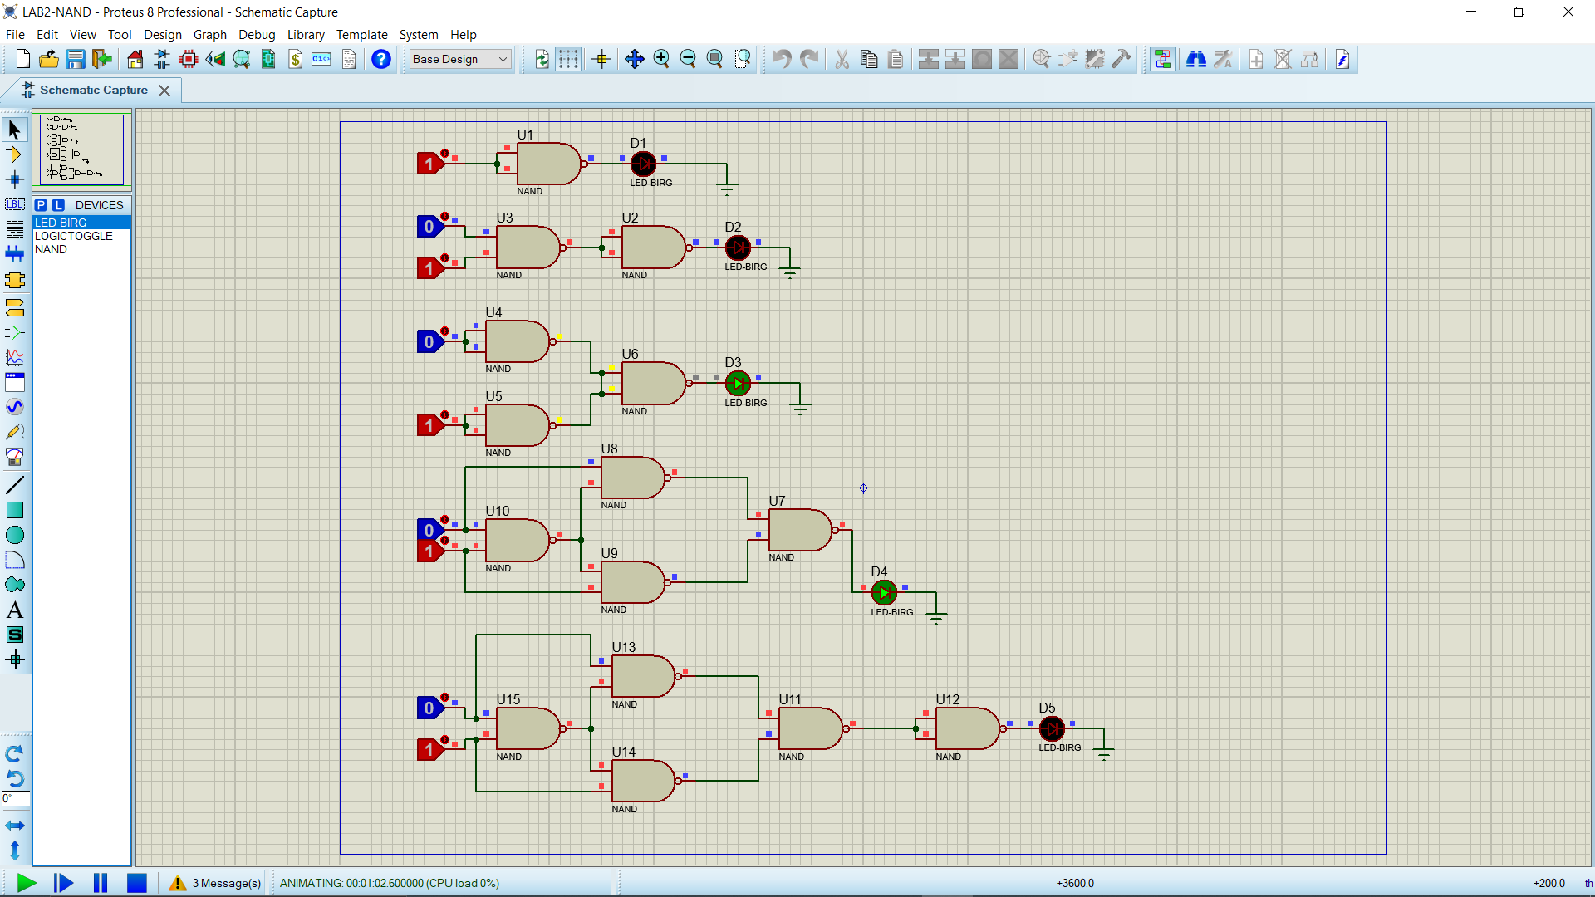

Figure 3: For Input A=0, Input B=1.

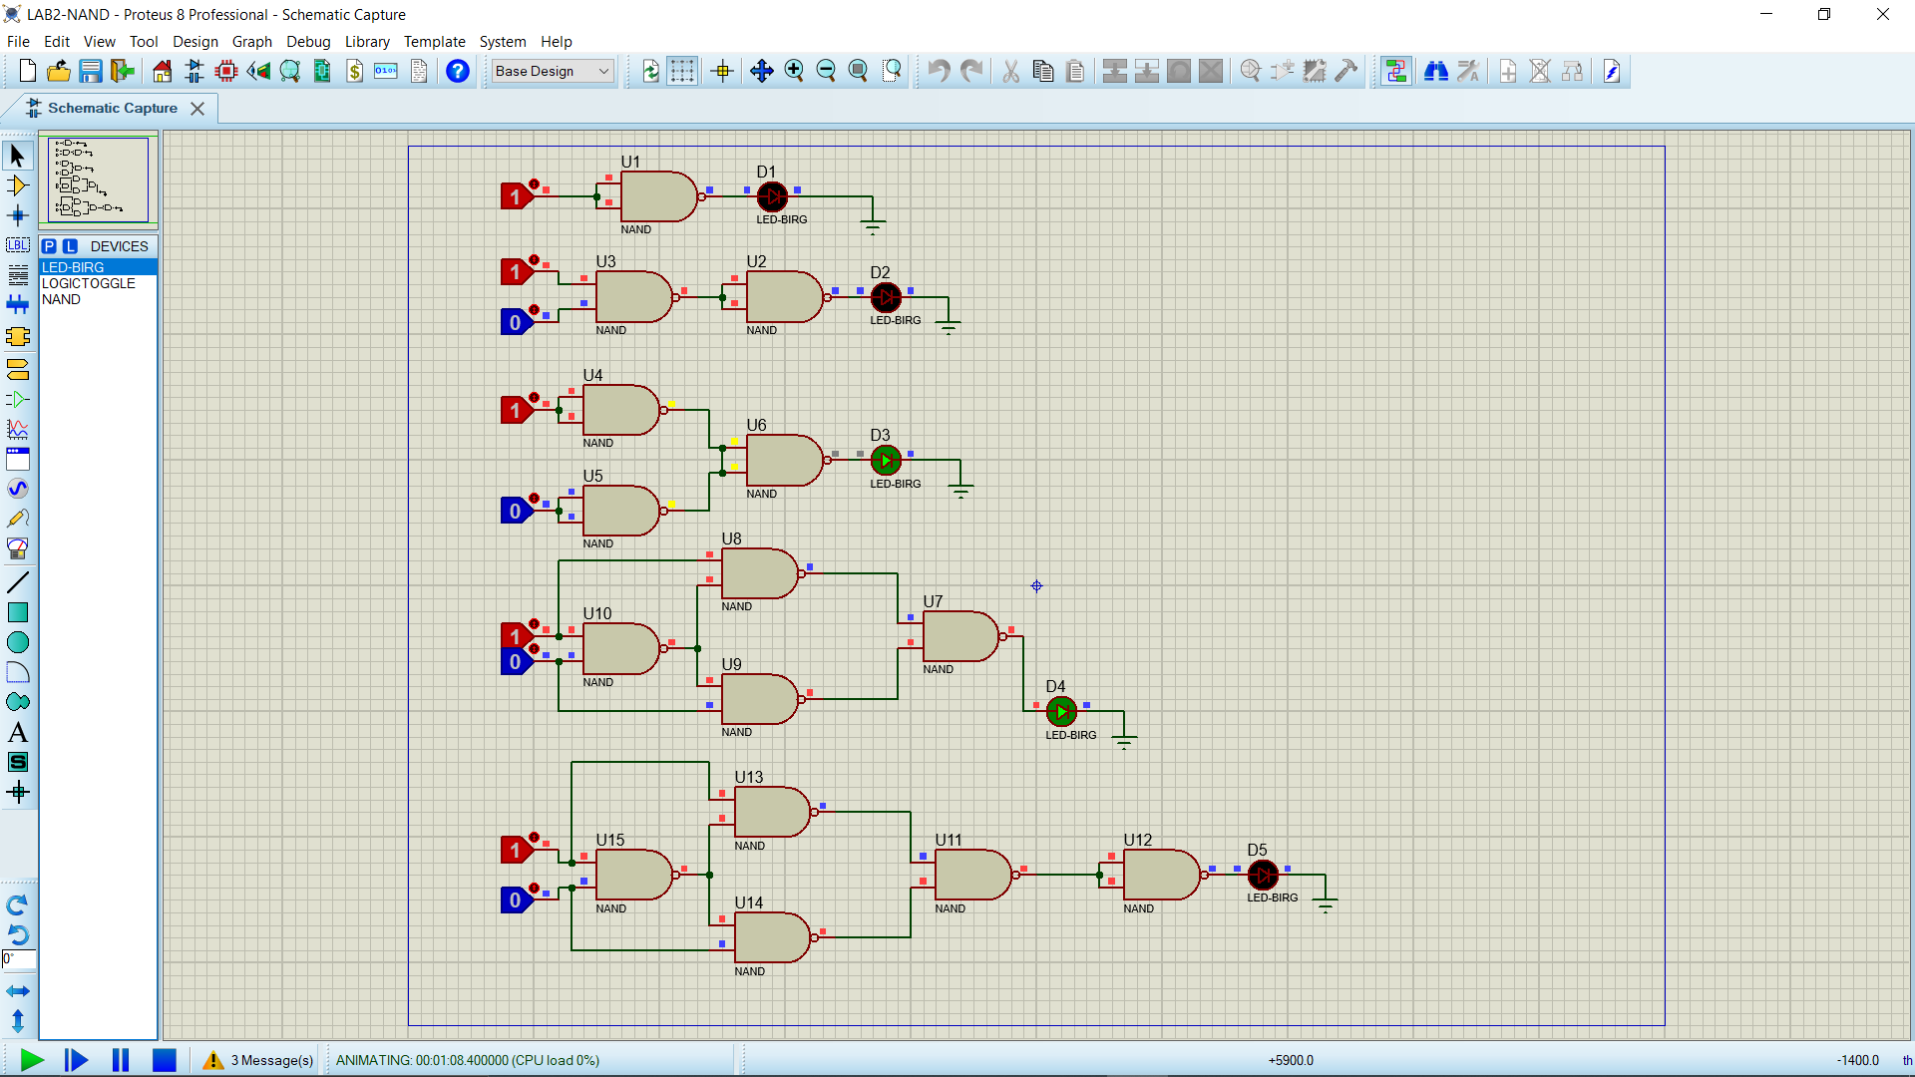

Figure 4: For Input A=1, Input B=0.

**NOR GATE**

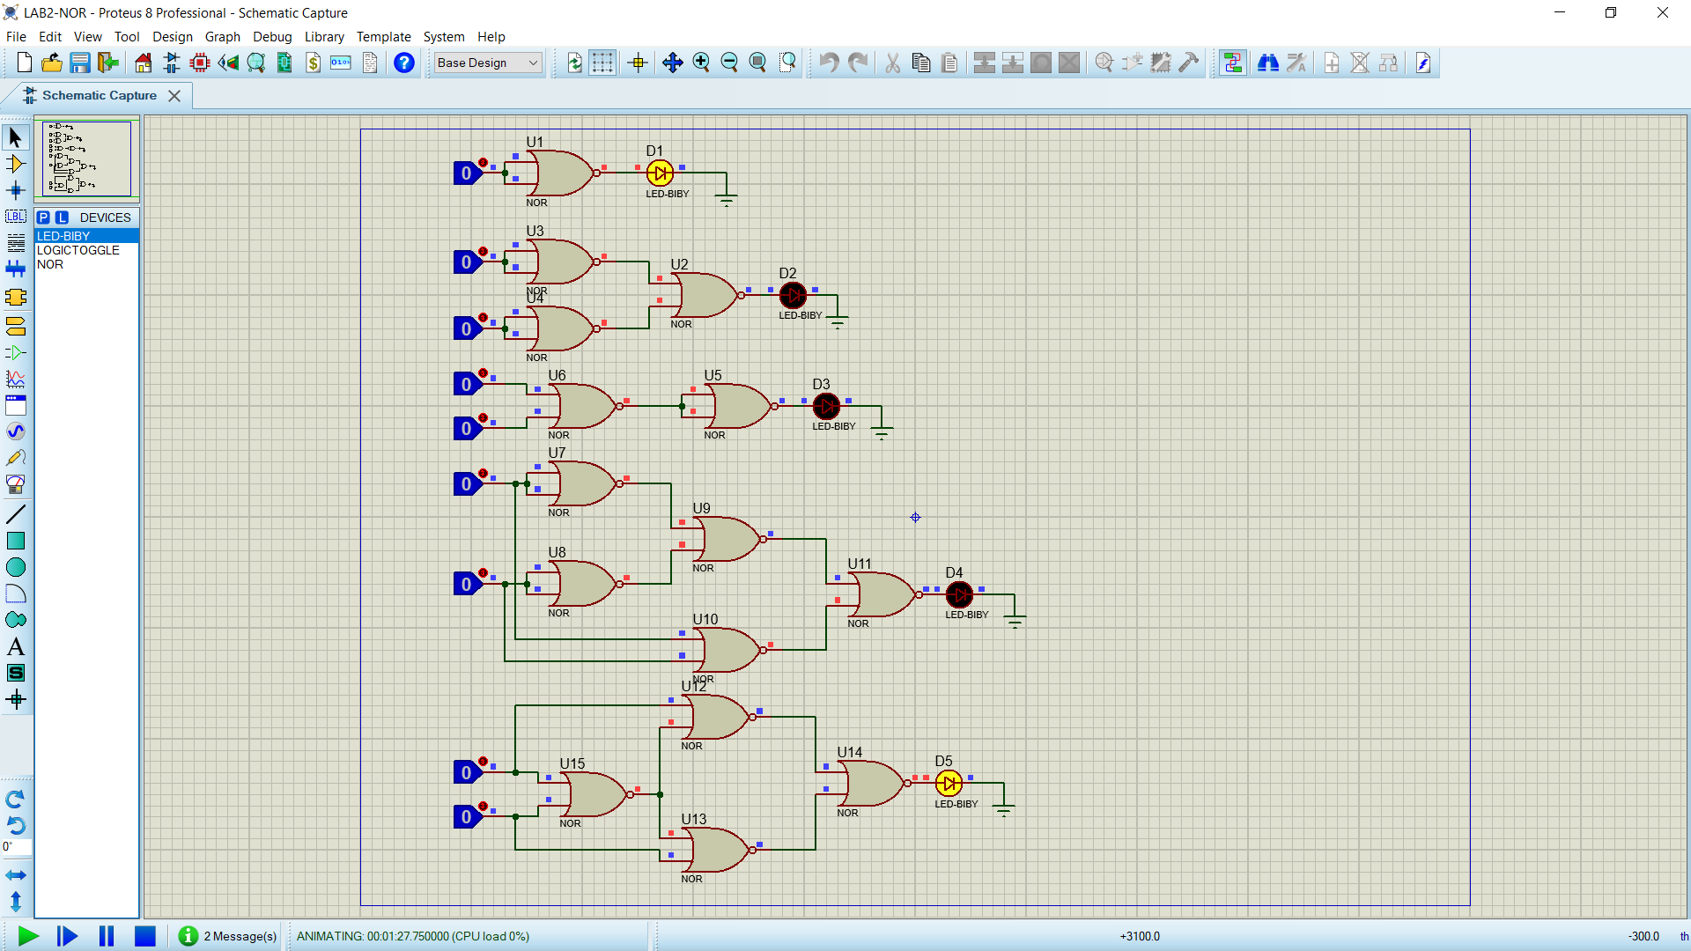

Figure 5: For Input A=0, Input B=0.

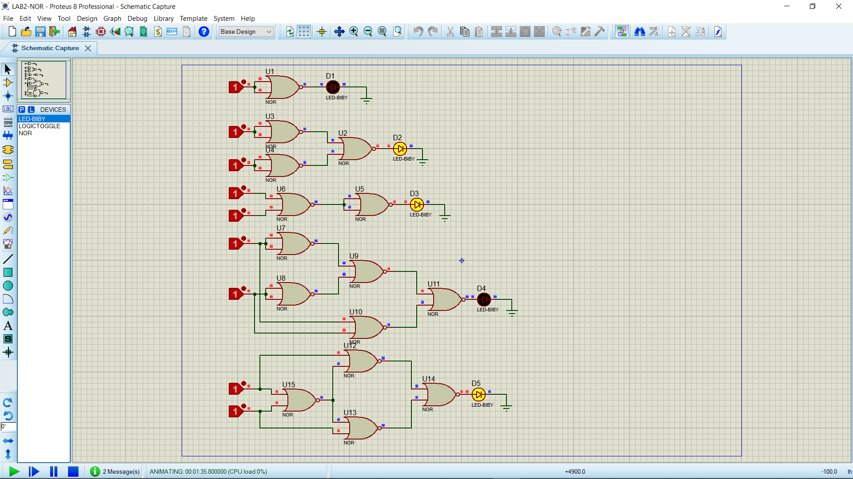

Figure 6: For Input A=1, Input B=1.

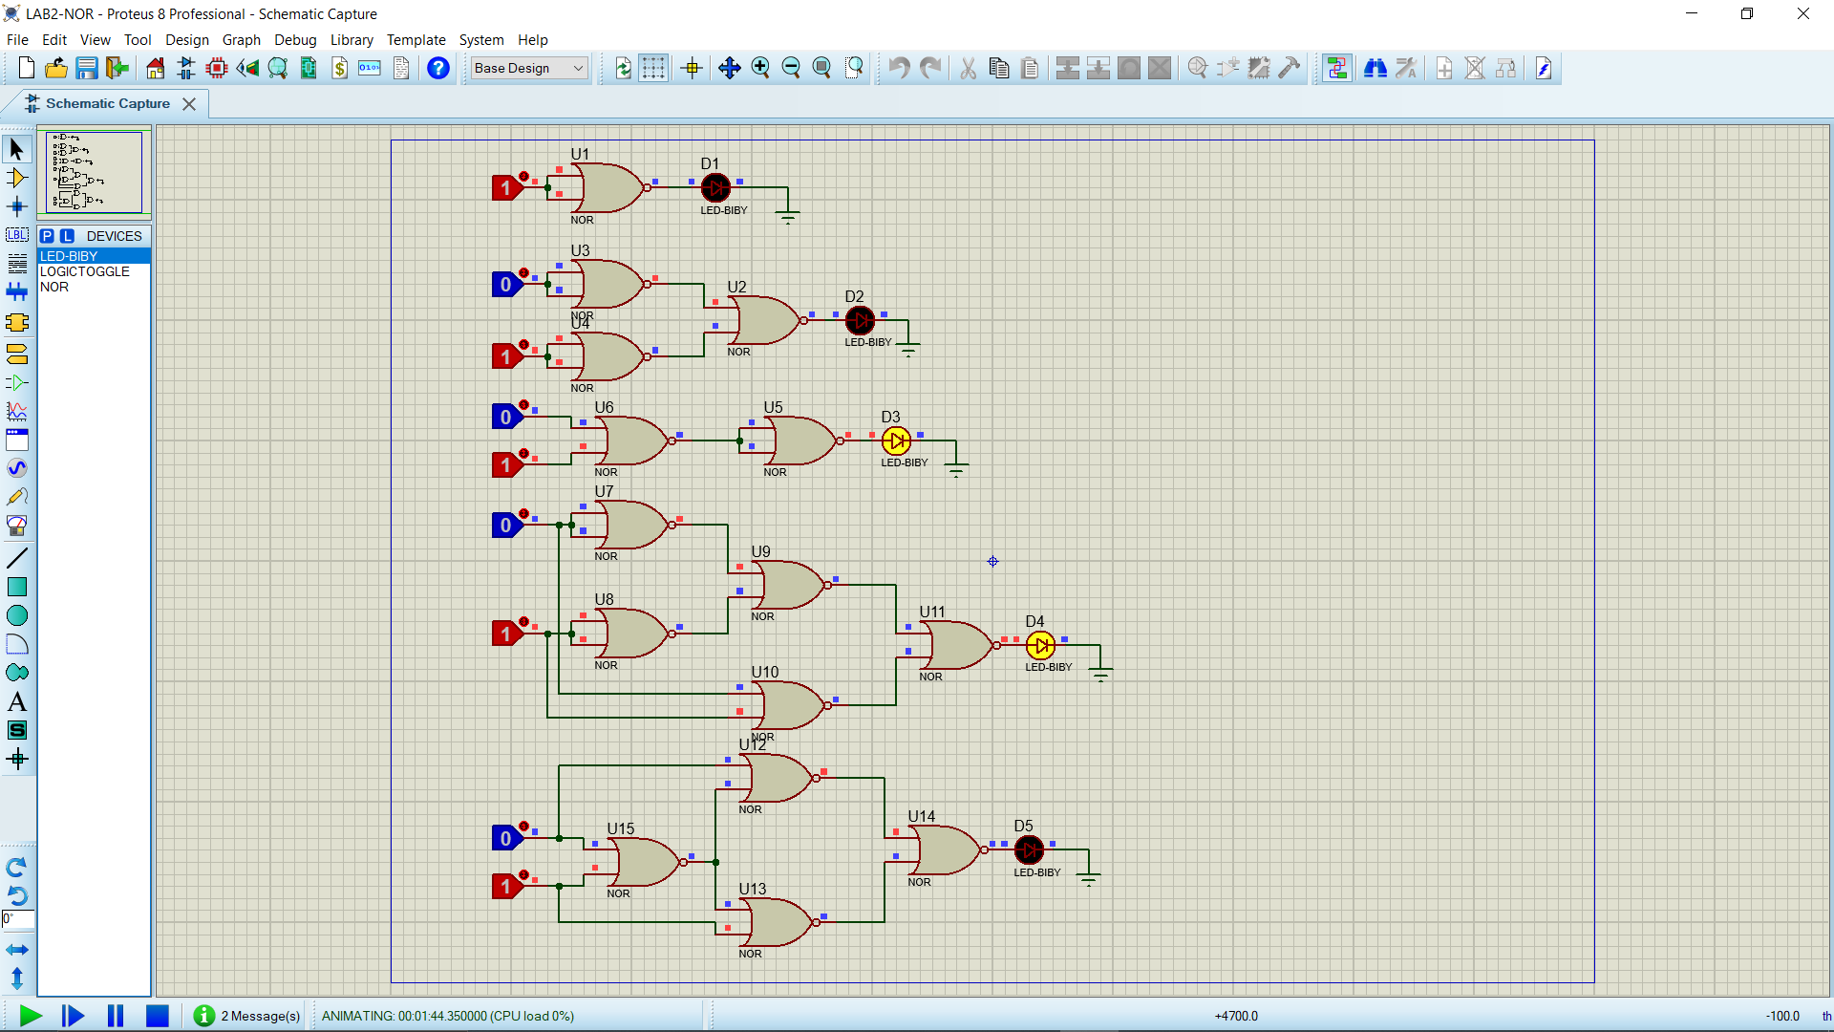

Figure 7: For Input A=0, Input B=1.

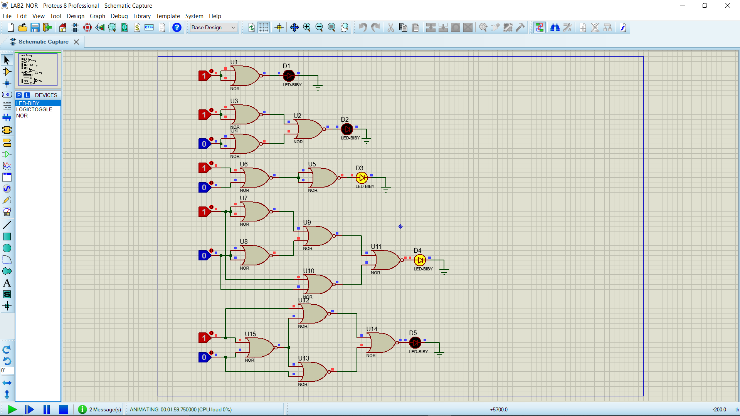

Figure 8: For Input A=1, Input B=0.

* 1. **Discussion:**

1. The NAND and NOR gates are universal gates.

2. We also learn that NAND and NOR gates are economical and easier to fabricate and are the basic gates used in all IC digital logic families.

3. An AND gate is typically implemented as a NAND gate followed by an inverter not the other way around.

4. An OR gate is typically implemented as a NOR gate followed by an inverter not the other way around.

1. **Question Answer:**
2. **What do you mean by universal gate?**

A Logic Gate which can infer any of the gate among Logic Gates. OR a gate which can be used to create any Logic gate is called Universal Gate.

1. **What are the ICs required in this experiment?**

IC 7402(NOR), IC 7400(NAND), 7404(NOT), 7408(AND), 7432(OR), KL 33002

1. **Construct a circuit of output F, where F=AB + BC + CA, by using NAND gates only.**

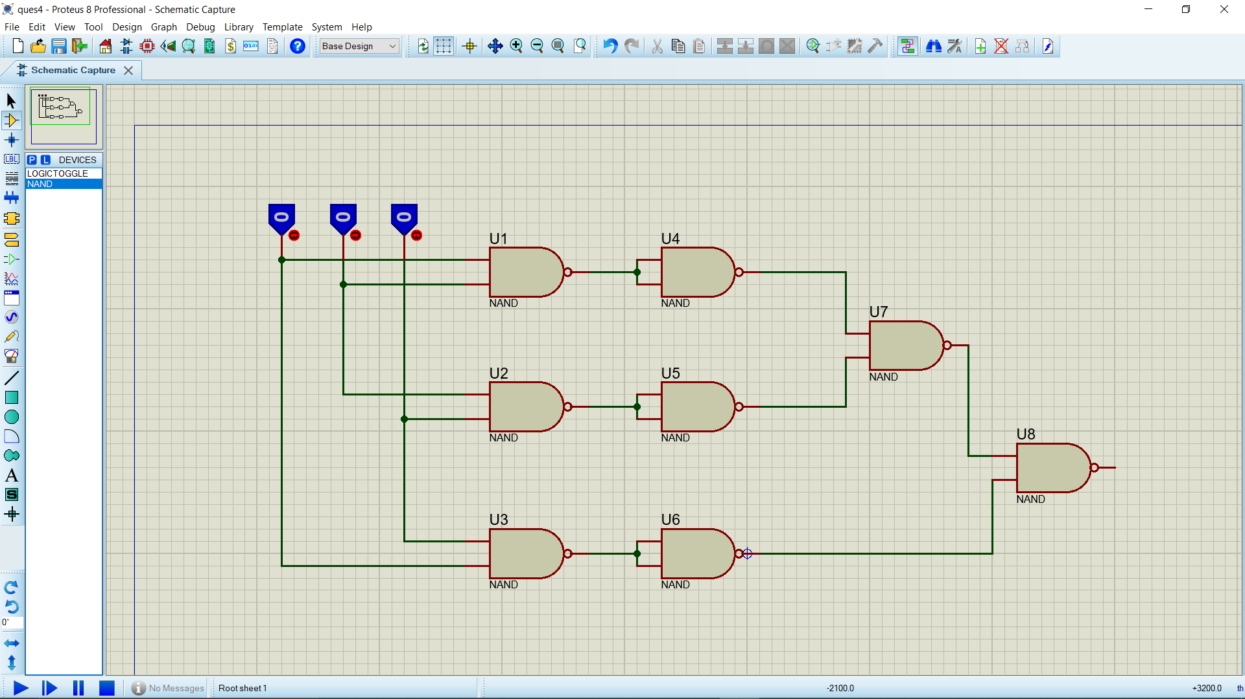

1. **Conclusion**:

Each group member conducted all tests (simulations) on their own equipment. Working with genuine ICs was not possible due to the online class. All of the tests were completed successfully. This lab aided in a better understanding of the gates. 1. In this experiment we learn that a universal gate is a gate which can implement any Boolean function without need to use any other gate type.

**Reference:**

1) www.tutorialspoint.com

2) www.electronics-tutorials.ws

3) faculty.kfupm.edu.sa

4) “Digital Fundamentals” by Thomas L. Floyd

5) American International University- Bangladesh’’ Digital Logic Design Laboratory

experiment 2 Laboratory Manual”.